Locations:

2nd Ave. – Known as Main Street in 1820. There wouldn’t have been powerlines, but the architecture was pretty similar.

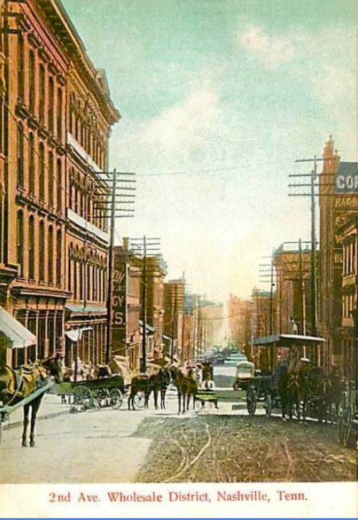

Docks – Just off of 2nd Avenue on the Cumberland River. This port was New Orleans’ biggest supplier and had plenty of people working nonstop to keep it going. In the 1820s, there wouldn’t have been steamboats but rather galleys and flatboats.

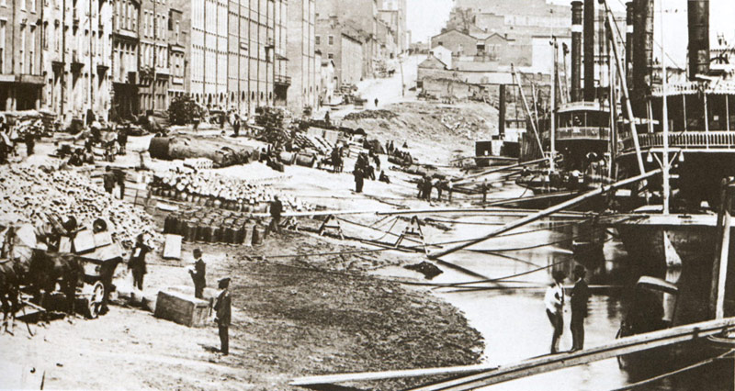

Black Bob’s Tavern – This was owned by Robert Renfro, a freed black man (which was really surprising in that day) who I’d like to have some dialogue since he has one of the most unique perspectives on slavery. There weren’t many cases of assault or other crimes, so this place would’ve likely been one of the more laid back kind of taverns. This is where the student can meet with Polk and discuss Polk’s Whig ideals.

